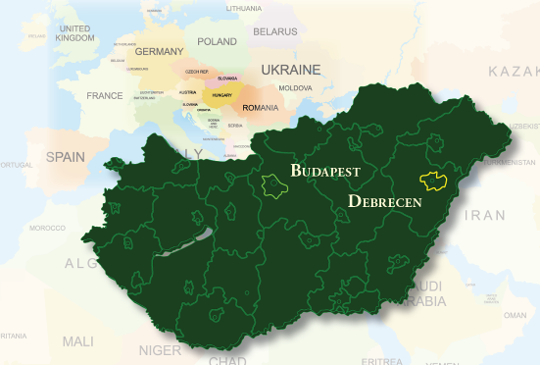
PRE-SUMMER HUNGARIAN LANGUAGE COURSE
40 class units, 4 ECTS credits

1–7 June 2014

Programme of Studies:
– Sunday to Friday 6 class units a day, on Saturday 4 class units,
45 minutes each
– groups of 1-6 students
– from beginner to proficiency level
– language of instruction at beginner levels: English or German
– tandem programme: chat with a Hungarian native speaker
– Summer School examination offered at the end of the course (ECTS credit points)

Dates & Reminders:
– registration: 1 June (Sunday), 8:00–9:00
– course starts: 1 June (Sunday), 9:00
– daily schedule:

Sunday  1 June | Monday  2 June | Tuesday  3 June | Wednesday  4 June | Thursday  5 June | Friday  6 June | Saturday  7 June
9.00–10.30 | 9.00–10.30 | 9.00–10.30 | 9.00–10.30 | 9.00–10.30 | 9.00–10.30 | 9.00–10.30
11.00–12.30 | 11.00–12.30 | 11.00–12.30 | 11.00–12.30 | 11.00–12.30 | 11.00–12.30 | 11.00–12.30
14.00–15.30 | 14.00–15.30 | 14.00–15.30 | 14.00–15.30 | 14.00–15.30 | 14.00–15.30

Accommodation and Meals:
– regarding accommodation, please contact the Summer School staff
– you can have lunch at the university canteen and/or nearby restaurants and dinner at nearby restaurants
– accommodation and meals are not included in the course fees

Course Fees:
Registration fee (non-refundable) | 30 EUR/person
Tuition | 400 EUR/person
The price of the teaching material (20-30 EUR) is not included in the course fees.

Application Deadline: 15 May

To apply, please send us a completed application form together with two passport photos and proof of payment of the 30 EUR registration fee.

Please read carefully the general information section before filling in your application form.

